Executive Biography
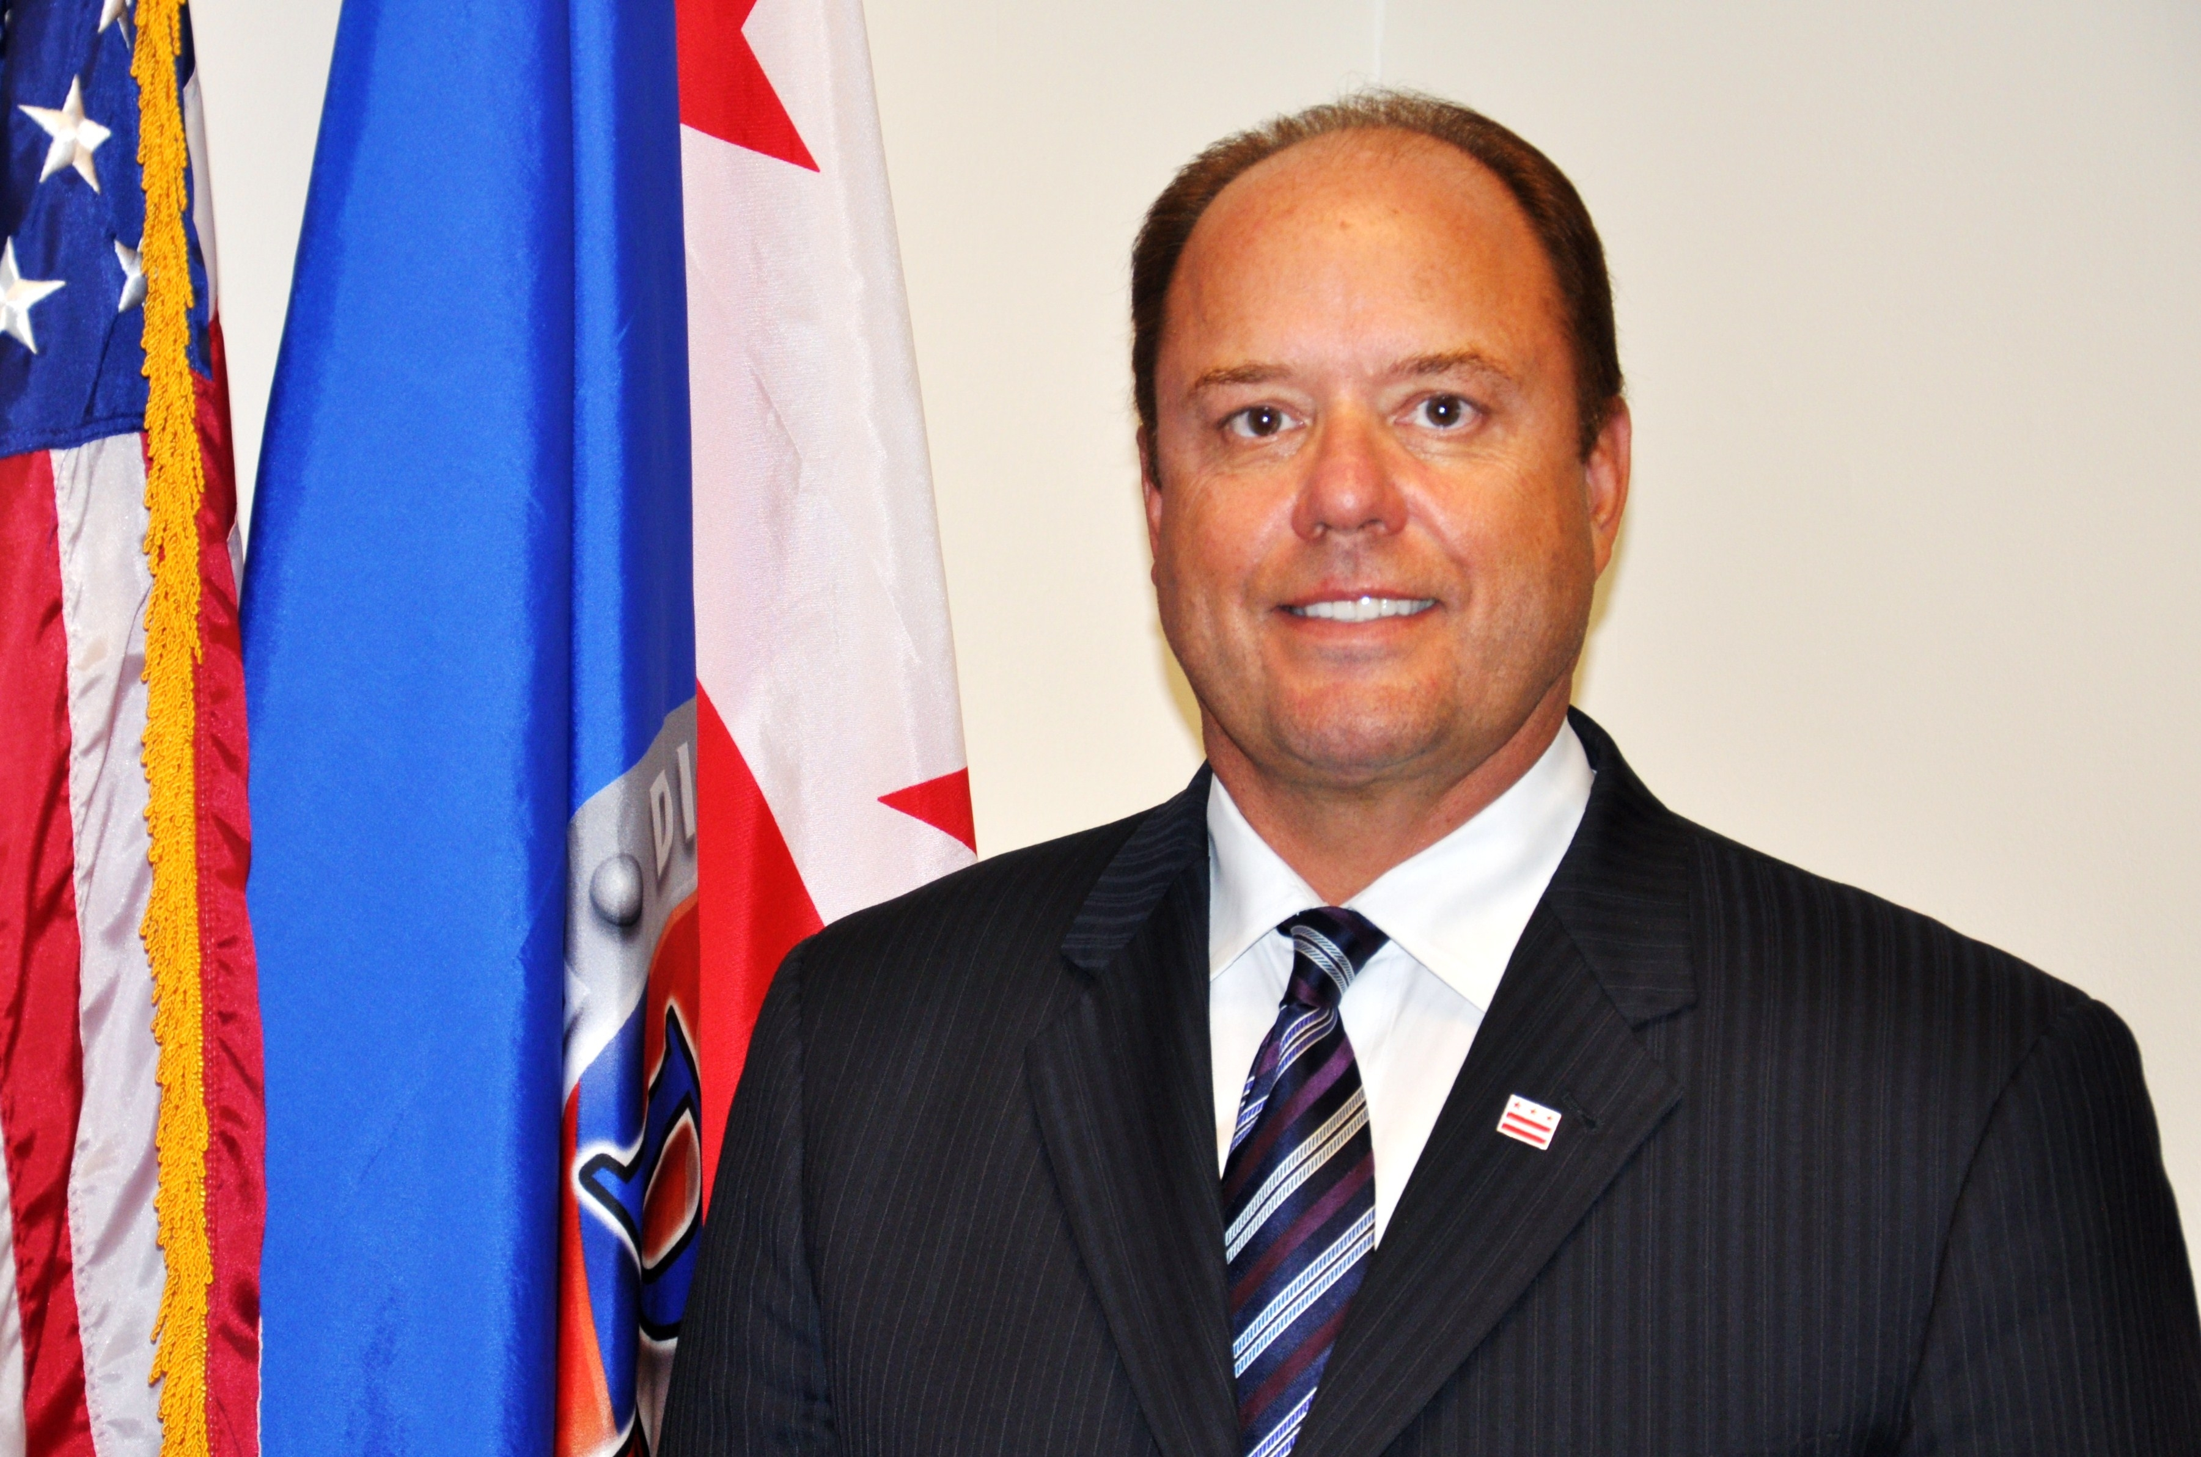
Thomas N. Faust
Retired Director, D.C. Department of Corrections
Retired Sheriff, Arlington County, VA
Past Executive Director/CEO, National Sheriffs’ Association

______________________________________________________________________________

Thomas N. Faust served as Director of the D.C. Department of Corrections (DOC), a Cabinet level position of the Executive Office of the Mayor. He served in this position from October 2011 to November 2016. DOC, a major component of the District’s public safety and justice cluster, is one of the largest local detention systems in the nation with responsibility for administering institutional and community-based correctional services. The Department has a $145M budget and 930 employees.

Mr. Faust joined the District government as an accomplished public safety and business executive with over 34 years of experience in the field of criminal justice and organizational leadership. From 1977 through 1990, he held multiple positions with the Arlington County Sheriff’s Office including Deputy Sheriff, Director of Administration and Chief Deputy. During this period, Mr. Faust provided leadership to a diverse team of public safety professionals and was involved in all facets of Departmental operations including all functions of law enforcement corrections, court security, and transport.

In 1990, Mr. Faust was elected to his first four year term as Sheriff of Arlington County, Virginia, a highly esteemed position he held for three consecutive terms. As Sheriff, he managed a multi-million dollar budget and was responsible for oversight of County-wide public safety strategies including corrections, law enforcement and judicial services. The sworn law enforcement and civilian employees under his supervision successfully carried out essential public safety functions.

As evidenced by his three time election to the position of Sheriff, Mr. Faust was seen as a proactive, inclusive and innovative public official with a commitment to quality service. He understood the importance of reaching out to residents and viewed his connection with the community, advocacy groups and other community-based organizations as a critical component of his mission. Staff from the Department maintained an ongoing presence in the community with participation in neighborhood-based forums and meetings seen as essential to the effective exchange of information with residents throughout the county.

During his tenure, Mr. Faust implemented a number of operational and programmatic protocols that led to the detention facility’s national accreditation by the American Correctional Association and the National Commission on Correctional Health Care. As Sheriff he was credited with a number of major accomplishments including the successful planning, design and opening of the county’s new jail facility and court/justice center; creation of the facility’s first emergency response team; establishment of a jail based substance abuse treatment program; implementation of the first jail based industries program in the state, and creation of a community based safety program for senior residents.

After leaving the Sheriff’s Office in 2000, Mr. Faust assumed the position of Executive Director/Chief Operating Officer (COO) of the National Sheriffs’ Association (NSA), a non-profit professional association representing over 20,000 members. As Executive Director/COO,
Mr. Faust was responsible for day to day operations, finance/revenue generation, legislative and government affairs, policy development, and federal grant administration. He was responsible for planning, directing and managing a coordinated national strategy for assuring support for the public safety missions of the Office of Sheriff in the United States. Under his leadership, the organization’s assets were doubled, grant funding for law enforcement initiatives was increased, online training programs for jail-based correctional certification and executive training and leadership development were launched. Direct assistance with Hurricane Katrina recovery was successfully coordinated and supported by Sheriff’s offices across the country.

Mr. Faust’s corporate experience includes work with Aramark Correctional Services as a V.P.
from 2007 to 2009 where he developed corporate marketing, outreach and quality assurance strategies. Most recently he was in private practice as a criminal justice and corporate consultant for organizations offering a range of public safety, corrections and market related services.

Mr. Faust received a Bachelor of Science degree from Virginia Tech and a Master of Public Administration from George Mason University. He has served on the George Mason University Administration of Justice Advisory Board; the Northern Virginia Community College Criminal Justice Curriculum Advisory Board, and the National Institute of Corrections Large Jail Network. Mr. Faust also served as Past President of the American Jail Association.

